**CHAPTER 3**

**PROJECT METHODOLOGY**

This chapter explained the details of the methodology that is used in making and implementing this project. This methodology is used to acquire the objective of the project that will produce a perfect result. To evaluate this project, the methodology based on Iterative and Incremental Development.

Nowadays, software development process is most commonly built around iterative and incremental approach. According to Techopedia website, iterative and incremental development is a discipline for developing systems based on producing deliverables. In incremental development, different parts of the system are developed at various times or rates and are integrated based on their completion. Project work is split into iterations that in every iteration included such phases as requirements analysis, design, implementation, testing, and functional requirements. The product is incrementally enhanced with additional functionality in every iteration. In iterative development, teams plan to revisit parts of the system in order to revise and improve them. User feedback is consulted to modify the targets for successive deliverables.

Iterative and incremental development is grouped into the following phases namely: Inception Phase, Elaboration Phase, Construction Phase, and lastly Transition Phase. In Inception phase, it deals with the scope, requirements, and risks of the project. In Elaboration phase, it delivers working architecture that moderates risks identified in the inception phase and satisfies nonfunctional requirements. In Construction phase, it fills the architecture components incrementally with product-ready code which can be produced during analysis, implementation, design, and testing of functional requirements. And lastly, In Transition phase, it delivers the system to the production operating environment.

The developers have chosen the iterative and incremental development model to develop the automated system for it suits best the developer’s development process of the project. Thus, iterative and incremental development model helps to reach project goals in the most efficient way.

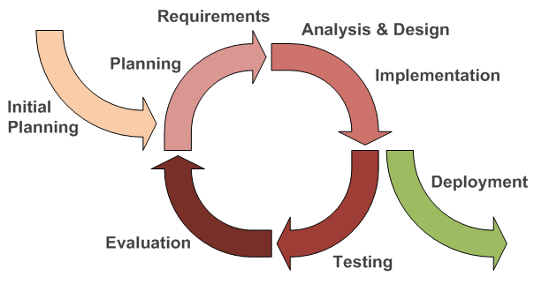

**Figure 3.1. Iterative and Incremental Development**

This figure showed the process in developing systems based on the producing deliverables through an iterative and incremental development cycle.

**3.1 Initial Planning**

In this phase, we interviewed fellow students, working students, faculty members of the Department of Computer Science, director of libraries, head of Audio Visual Center, officer-in-charge of libraries, and the technician of Audio Visual Center at University of San Carlos Talamban Campus about our proposed system. After identifying the process, we determined the system requirements as what our respondents and adviser recommended and identified the problems encountered while using the manual reservation of Audio Visual Rooms and Assets management system.

**3.2 Define Requirements**

In this phase, we analyzed all the information gathered with the documentation of the project, interviews, and all needed data and came up with the solution to the problem. We established the kind of system that should be developed for the future University of San Carlos Audio Visual Center Asset Management and Reservation System after studying the University’s manual business process flow.

**3.3 Analysis and Design**

In this phase, we started creating lay-out, design, module, and prototype that will be needed for the efficiency of our proposed Audio Visual Center Asset Management and Reservation System. We created Flow Chart, ERD (Entity-Relation Diagram), Use Case Diagram to fully understand the flow of the University of San Carlos’ manual process into our proposed system.

**3.4 Implementation**

In this phase, we had already noted the requirements required by our respondents and adviser for the improvement of our Audio Visual Center Asset Management and Reservation system. We find out that there are problems encountered during the process of the system. Functions were also added to meet the requirements of the system.

**3.5 Testing and Evaluation**

In this phase, we are ready for testing our proposed Audio Visual Center Asset Management and Reservation system. We gathered all the testing results to identify from the different users of the system and were able to identify if there are any problems found in the proposed system. Evaluation from the users was made after testing the system in line with the system requirements.

**3.6 Deployment**

In this phase, we and the client will settle on if the system is ready for deployment or the system will undergo revisions for improvements. If the system is ready for deployment, we will present a user manual and conduct training on how to use our proposed system.